# DIY Anemometer with a DC motor and Arduino / wind speed measurement

Accurate measurement of wind speed is difficult to achieve because of many factors like calibration needed by sensor which use the principle of induction/generation to measure the wind speed.

Here I have repurposed a small dc motor to generate a pulse with each revolution. This sensor doesn’t use the induction principle, instead it uses conduction which happens between the split rings and brushes of a dc motor.

## Working principle/ idea

The idea for this sensor is that upon one revolution the sensor should produce one pulse(5v). This way by measuring the duration between two rising pulses we will be able to calculate the time taken to complete one revolution and thus wind speed.



Figure Arduino Serial plotter window

Lets First see the construction of a Dc motor.

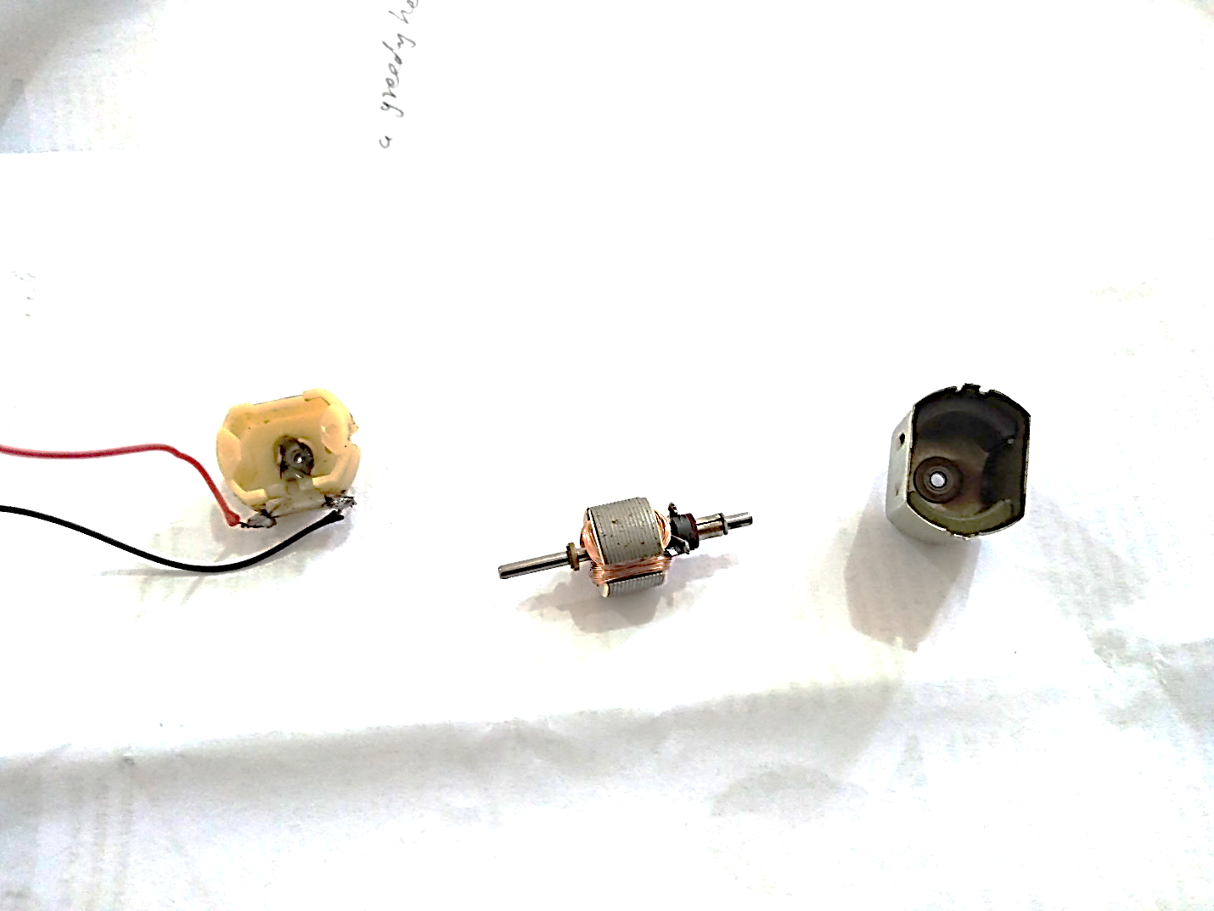

Figure Back cover with Brushes, Armature, outer case with Permanent Magnets

Our parts of interest here are only brushes and split rings. We are going to remove rest of the things.

* Remove coil from the armature (Figure 3)
* Remove permanent magnets from the outer casing (Figure 4)
* Remove one of the brushes and keep one (we only need one).
* Notice that the split ring has three parts, Remove two of them.(Figure 3)

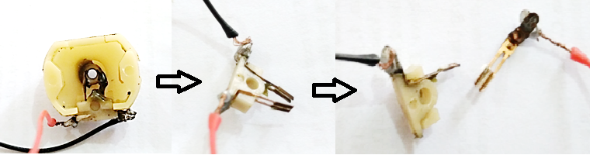

Figure Removing one of the Brushes

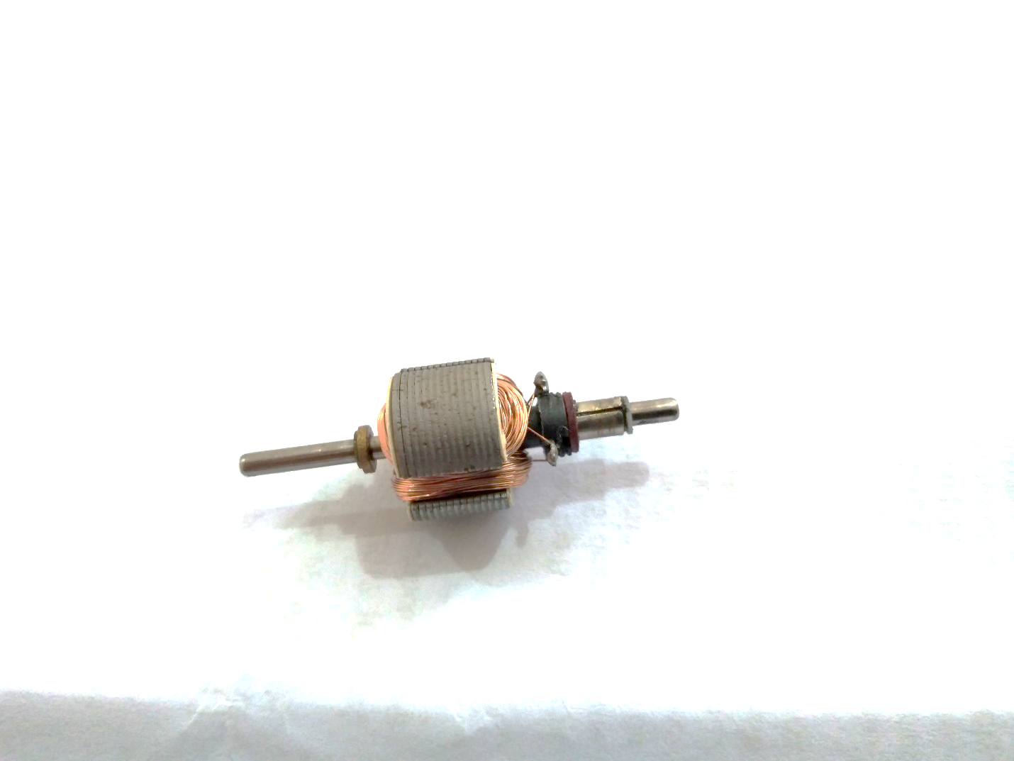



Figure Remove the coil from armature and notice the 3 parts of split ring

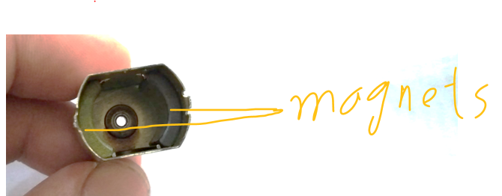

Figure Permanent magnets

Notice the shape of this brush, it has two connection points. now we cut this brush from the middle and make two separate (insulate them) brushes with this.

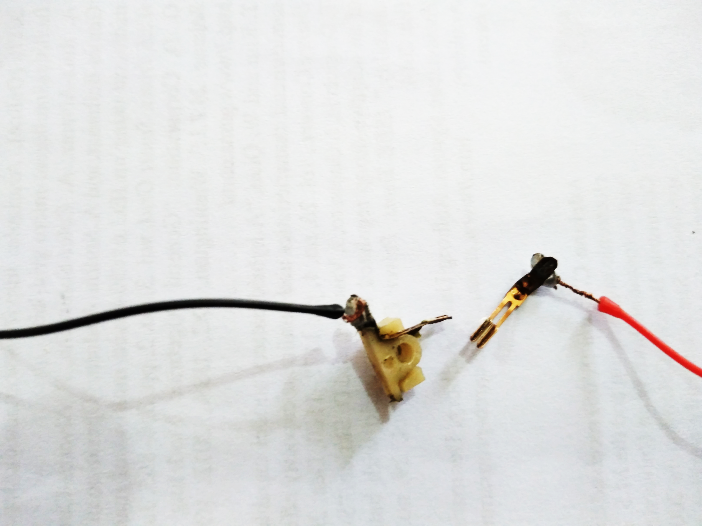

Figure one of the brushes

Now insert both of them to the one of the slots shown below. But this time they should not be connected to one another.



Figure Brush slots

